DISCLOSURE OF INVENTION

- Particulars of inventor(s)
S. No. | Name of the Inventor(s) | Organization / department and designation (if applicable) | Nationality | Email and Phone number
1 | Mr. Deepankar Sharma | Department of Computer Science and Engineering,  Graphic Era Hill University, Haldwani | India | deepankarsharma.20041299@gehu.ac.in
2 | Ms. Sujata Negi Thakur | Department of Computer Science and Engineering,  Graphic Era Hill University, Haldwani | India | sujatanegi@gehu.ac.in
3 | Mr. Manoj Kumar Singh | School of Computing,  Graphic Era Hill University,  Bhimtal | India | mthakur@gehu.ac.in

- Kindly attach more sheets if required
- Please feel free to attach additional drawings if needed to explain your response(s). In addition, please attach any supplemental materials that you think might help illustrate your invention.

- Particulars of invention

- Title of the invention
Method and System for Baby healthcare using Reinforcement Learning

- General purpose of the invention:

The lives of people is already getting busier everyday. In most families involving both parents working are prone to insufficient parenting, as small babies can’t exactly say what they want and parents might be too busy to figure it out.

- Flowchart, process, method, algorithm and diagram of the invention

- Community app
- Reinforcement learning

Small babies
(Can’t say what the want)
Not every parents know the best
- Specially first time

Community
(advices from fellow parents)
comments
Learn according to the child

APP

Happy / sad / other
Identify emotion
- Happy/sad/other
Recommend melody
- Happiness score
- Seems Hungry?
Give food !!
- Looks Healthy?
- Tips and Tricks
Nice cheeks :)

- Abstract

The idea is to develop a full-fledged AI automated application with a Facial Mood Detection Classifier trained specially on datasets of small babies which can help you detect the current mood of the baby that whether they are happy/sad or they seem to be hungry. The app will also have another features like growth-vs-age mapping of various children that can help you track the growth of your child, The voice of child is supposed to be another useful task for the purpose.
This app is supposed to be serving as a self-customized application which will learn to deal with specifically your child. It would be made flexible so that with time it’ll learn from habits of the specific children it’s serving to.
Another feature , the app will come with a community environment , where you can seek for advice from fellow parents/experts. Everyone knows some life hacks, so the users might will have possibly many many better options of childcare.
The application will also have various inbuilt melodies and songs as well as access to music applications or youtube which it can play/recommend according to the mood of the child.

Signature of Applicant
Dt:
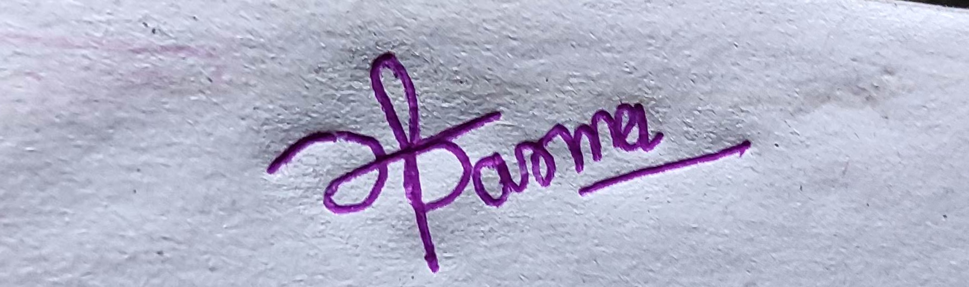
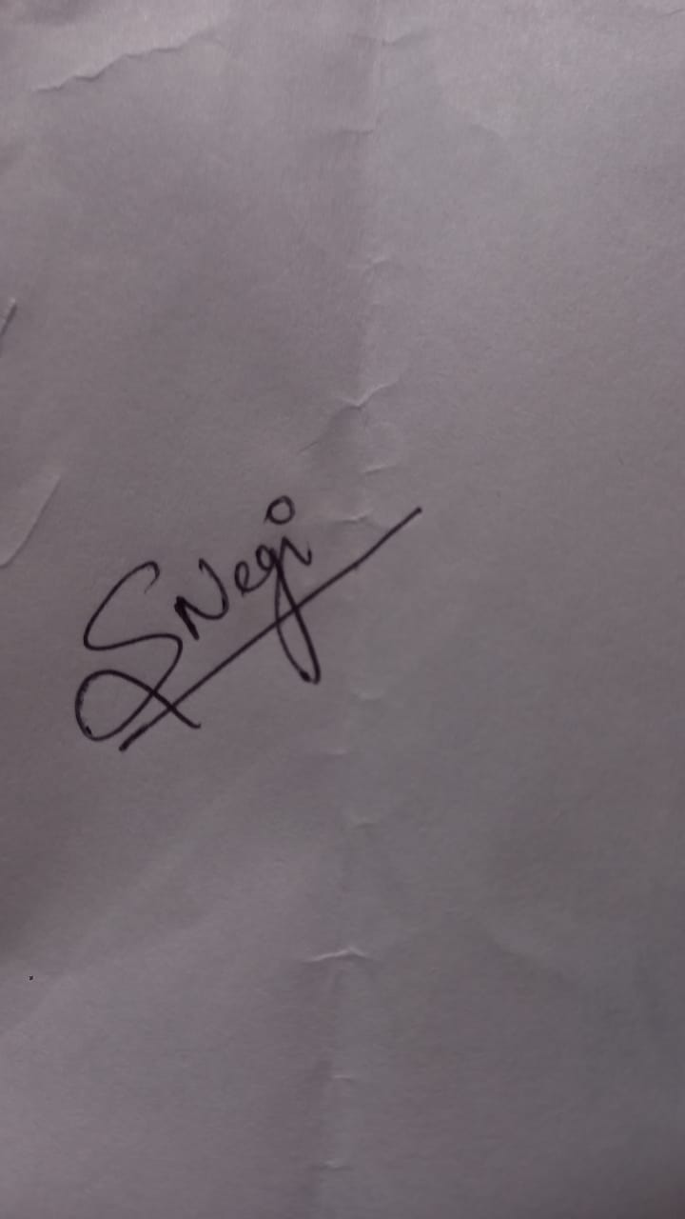
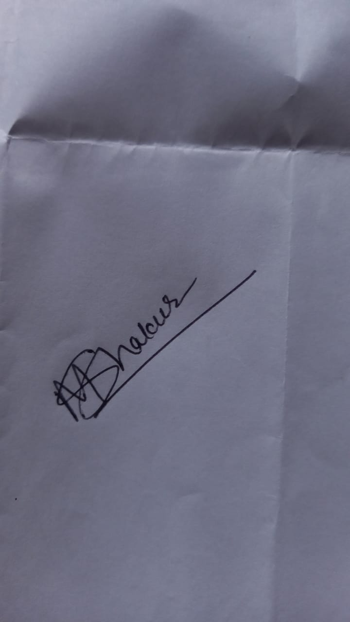

Remark of IP Cell

Signature IP Head

Remarks of Dean Office

Signature

